**PROBLEM CONTEXT UNDERSTANDING.**

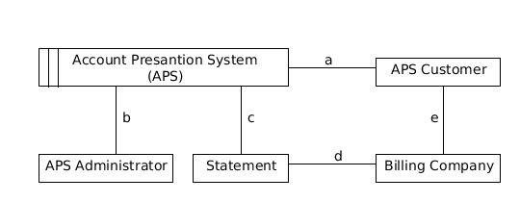

The APS Administrator, APS Customer, Statement, and Billing Company represent the physical domains (the problem world) that the APS is targeted for. Each relationship between a given domain and the APS is crucial in the derivation of the APS specification. Below is high level description of the relationships identified.

**A . Customer and the APS**

* A customer has to sign up/register with the APS.
* A customer performs configuration of their statement viewing.
* A customer can view their statements.

**B. Administrator and the APS**

* An administrator schedules the APS for scraping.
* An Administrator resolves APS errors.

**C. APS and a Statement**

* The APS retrives account statement data via a scraper.
* The APS generates a statement.

**D. Statement and the Billing Company**

* A statement's data originates from a billing company.

**E. Customer and the Billing Company**

* A customer has an account with a billing company.

**High LEVEL USER STORIES.**

**Sign up**

**As a:**

**I want:**

**So that:**

**Configure Statement Viewing**

**As a:**

**I want:**

**So that:**

**View Statement**

**As a:**

**I want:**

**So that:**

**Schedule Scraping**

**As a:** APS Administrator.

**I want:** I want to configure a scraping schedule for the APS.

**So that:** The APS can periodically scrape data.

## Scrape Schedule Specification

**GIVEN:** The billing company’s website maintenance window is known

**AND:** The billing company’s website peak demand periods are known

**AND:** The number of days per billing cycle for the billing company is set.

**AND:** The retry interval following unsuccessful scrape is set.

**WHEN:** A billing company’s website is scheduled for scraping

**THEN:** The scrape scheduling executes successfully

# Examples:

|  |  |  |  |  |  |
| --- | --- | --- | --- | --- | --- |
| **Billing Company Website** | **Open Window** | **Peak Periods** | **Billing Cycle is set** | **Retry Interval is set** | **Schedule** |
| Municipalities | Yes | No | Yes | Yes | Yes |
| Municipalities | No | No | Yes | Yes | No |
| Municipalities | Yes | Yes | No | No | No |

**Retrive Statement Data**

**As a:**

**I want:**

**So that:**

**Generate Statement**

**As a:**

**I want:**

**So that:**